**ASSIGNMAENT-7**

Name:Suraj Kumar

PRN: -240840127041

**Q.1 create a partition called "exam partition"; make one compute node a part of it ; on this compute node this will be default partition for wall time 7 days and will be available for 10 minutes for a given job ; execute the job provide detailed information about a job and partition; take screenshots for upload**

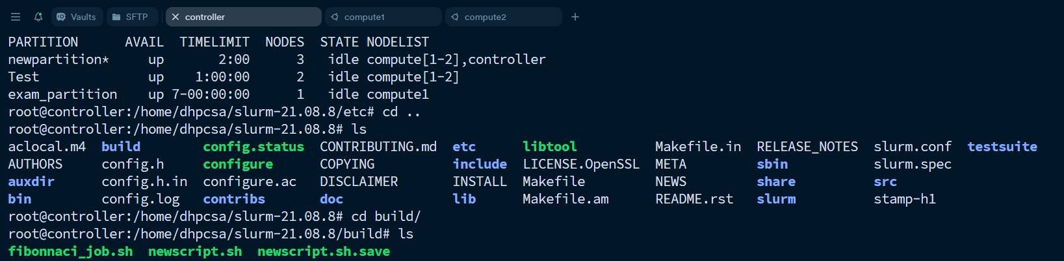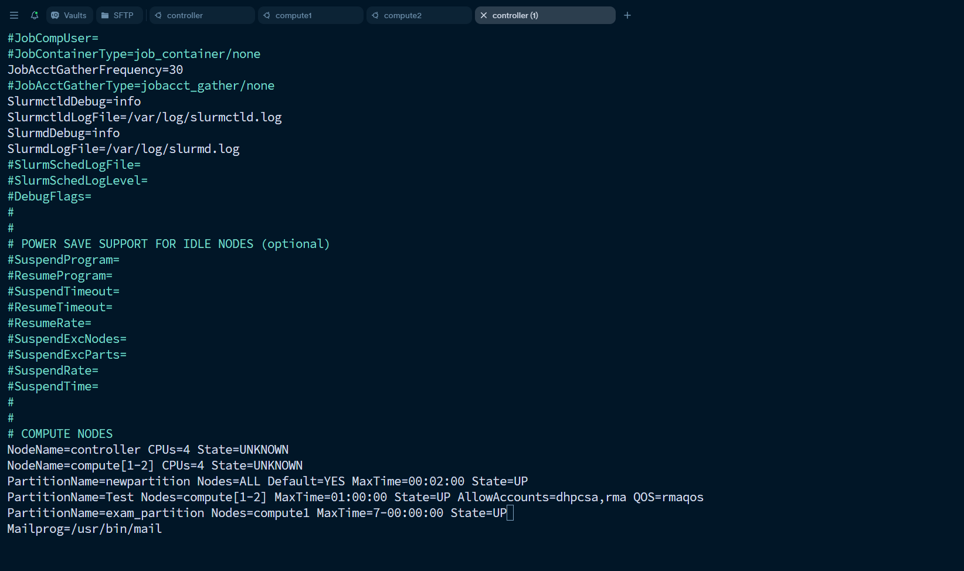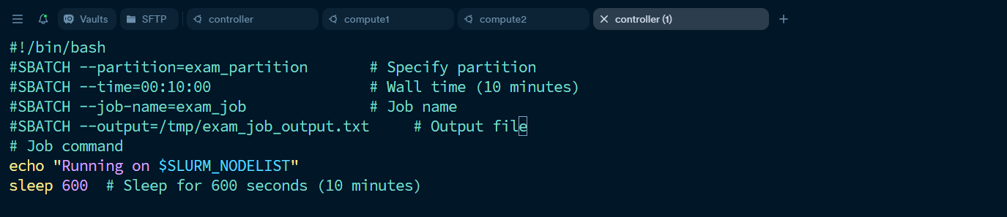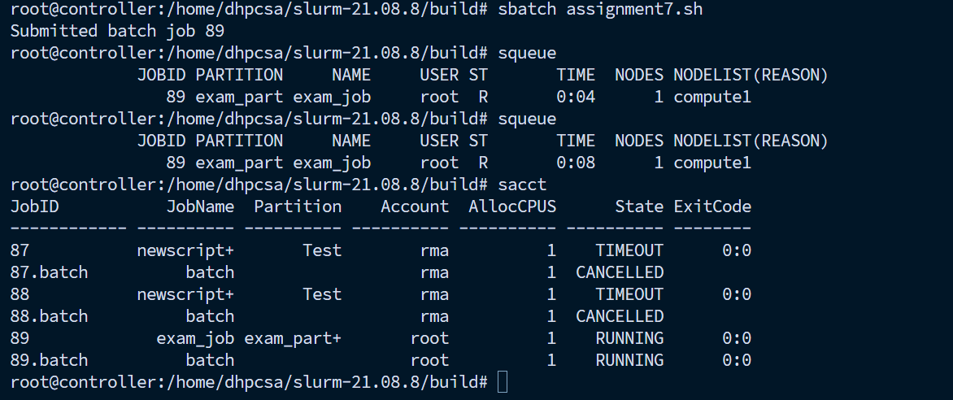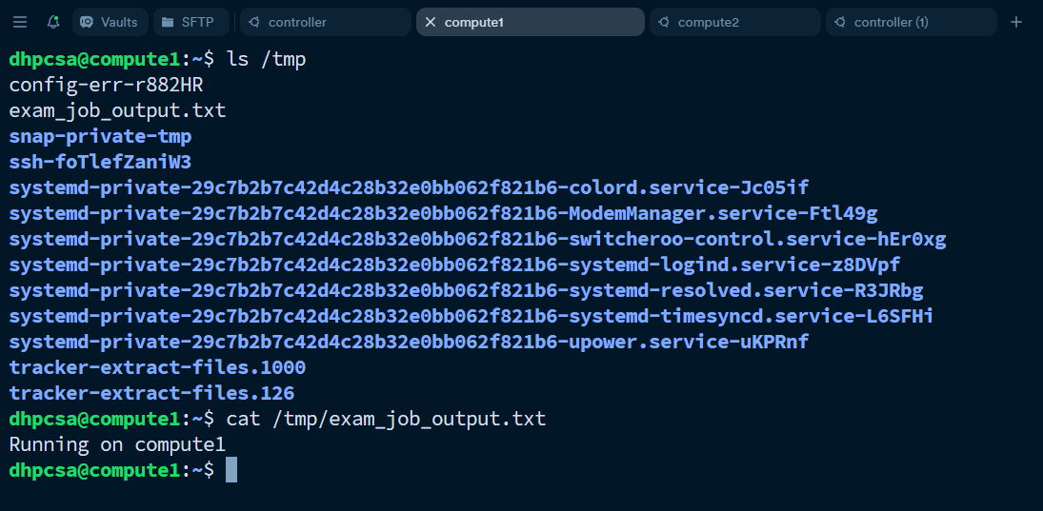

**Q.2 The user "examuser" must be able to submit only two jobs for "exam partition"; validate your output with squeue or scontrol show jobs**

### **1. Create a New User**

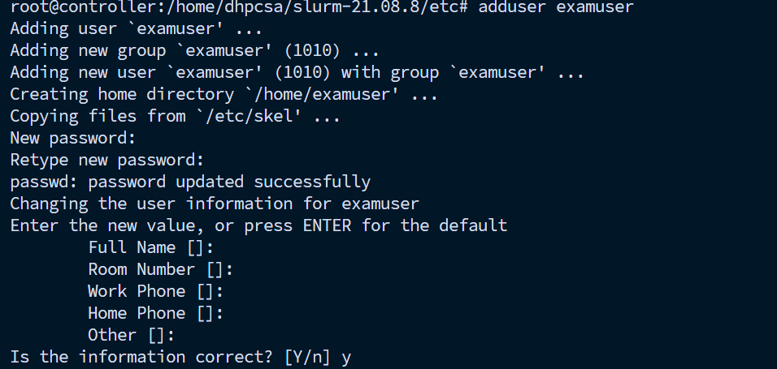

### **2. Editing the Configuration File (slurm.conf)**

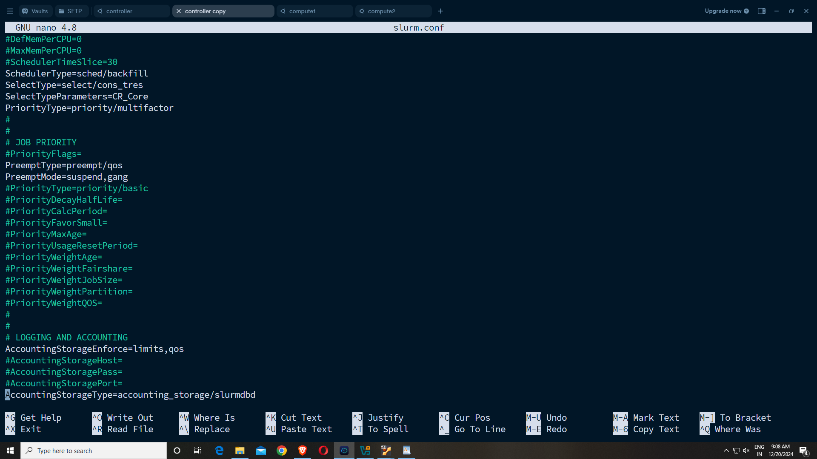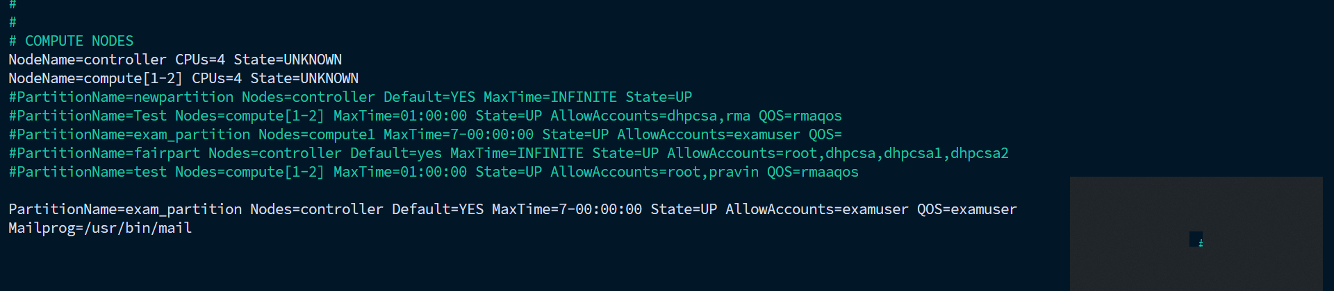

### **3. Make Scripts to Run**

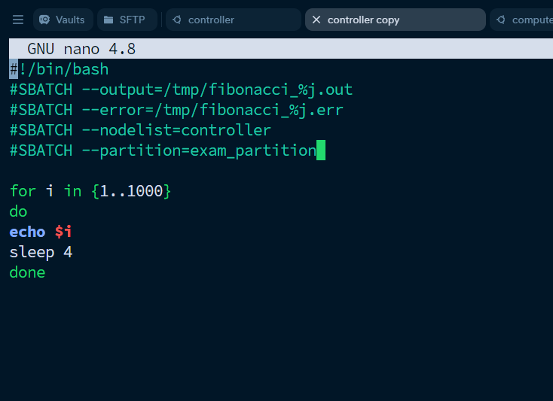

### **4. Copy Configuration to System Directories**

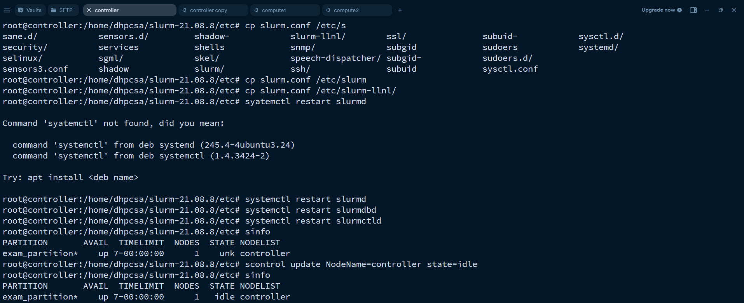

### **5. Restarting Slurm Services**

After editing the configuration, the Slurm services were restarted:

systemctl restart slurmd

systemctl restart slurmdbd

systemctl restart slurmctld

### **6. Create Account and User in sacctmgr**

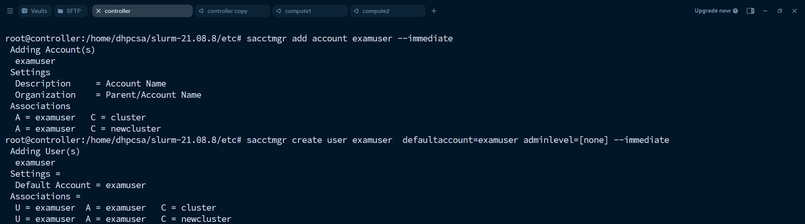

### **7. Create QoS for the User**

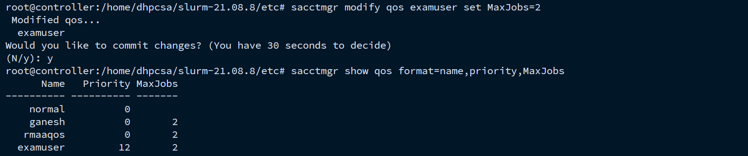

### 

### **8. Modify User Settings (MaxJobs)**



### **9. Check QoS Settings**

sacctmgr show qos format=name,priority,MaxJobs

### **10. Submitting Jobs as examuser**

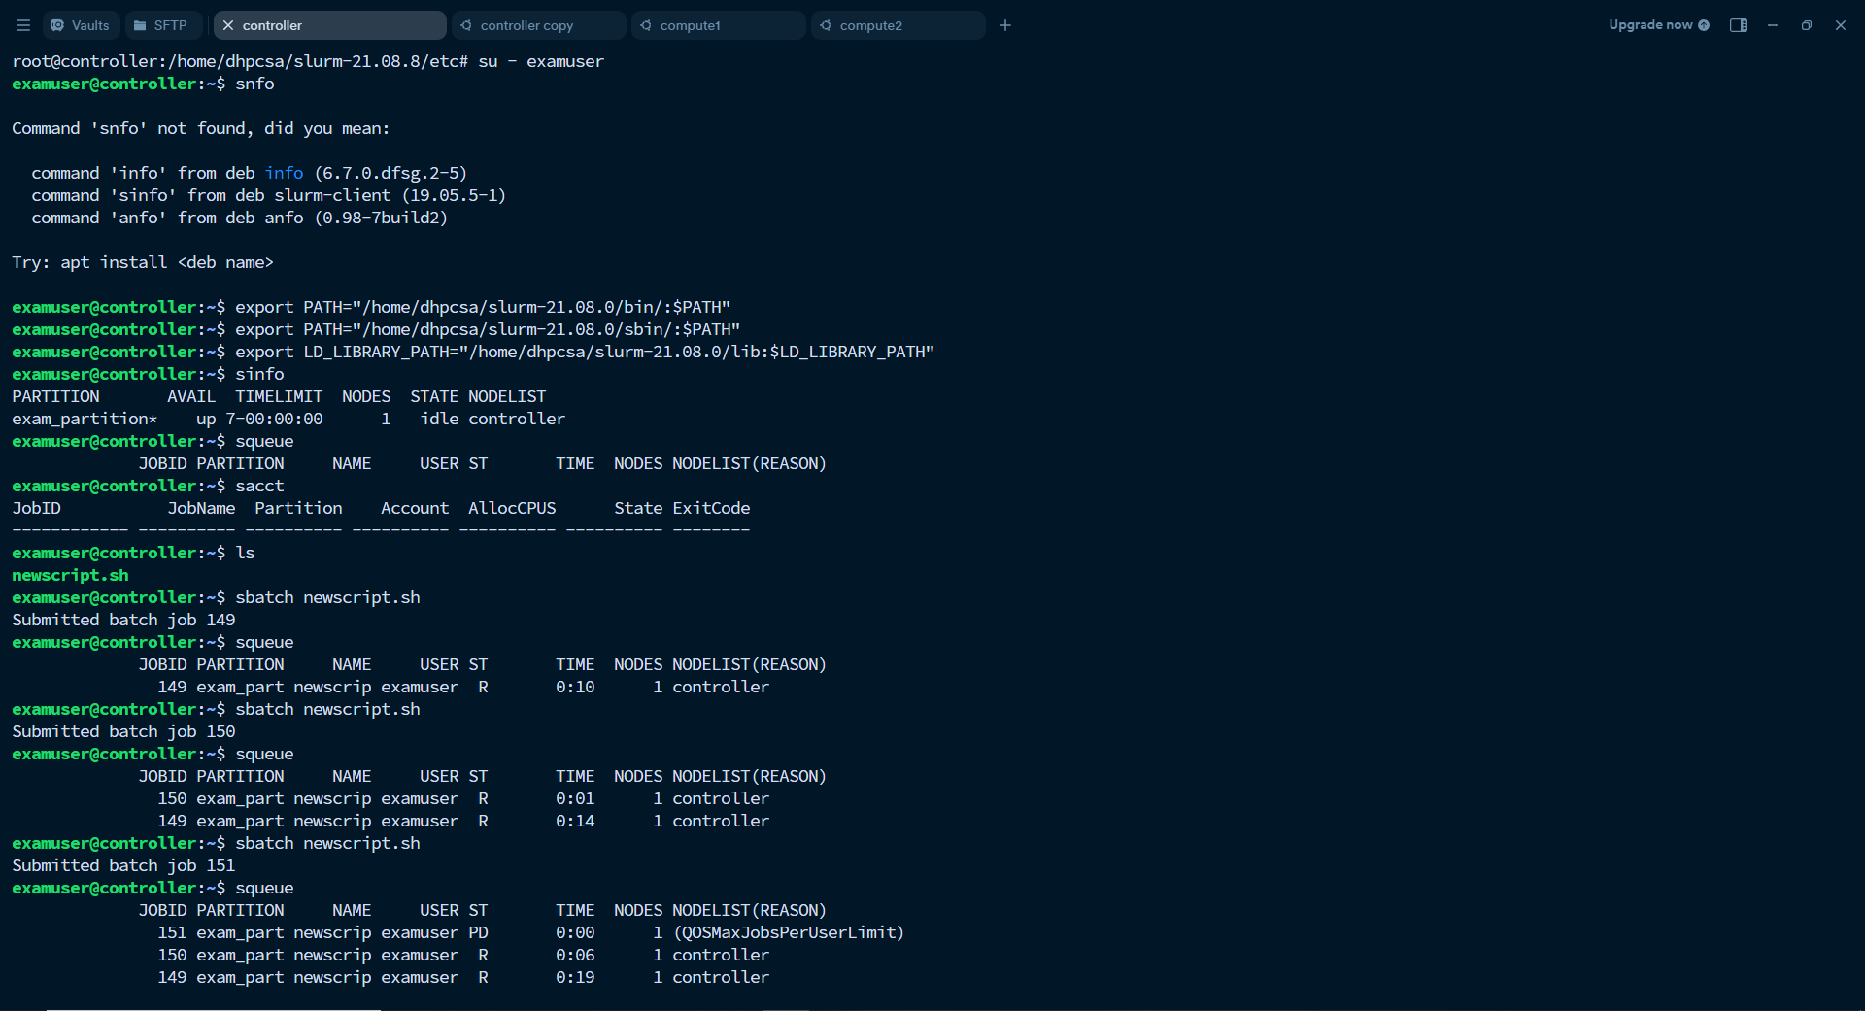

### **11. MaxJobs Exceeded (QoS Limit)**

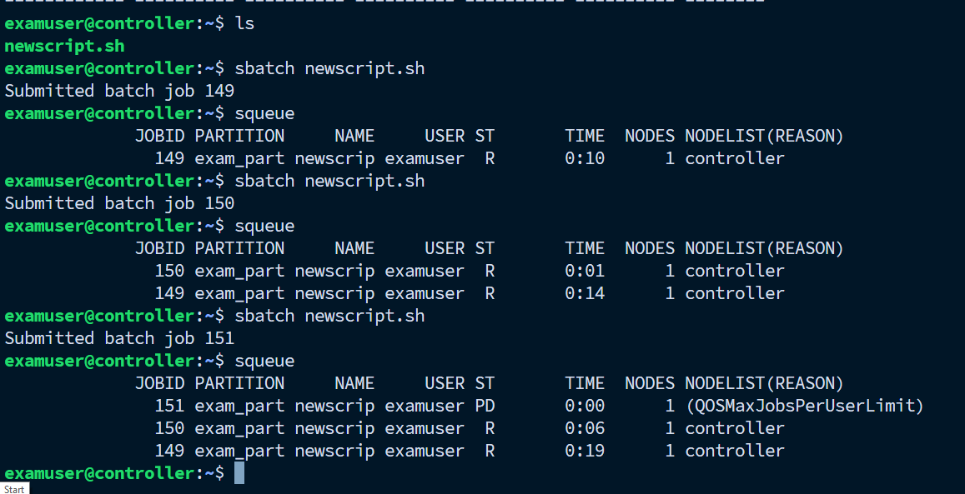

**Q3) Create a slurm account "exam account" and add "newexamuser" in it and submit a job by specifying account name**

